

**M. Tech. in Software Engineering**

**Cross Platform Application Development**

**SEZG585**

**Flutter App with Back4app Integration**

**Name – Hemant Tiwari**

**BITS Student ID – 2022MT93184**

**Semester – 1st FY 2023-2024**

Make sure everything is installed properly by running flutter doctor command.

Make sure parse-server-sdk version is same in your flutter application (pubspec.yaml) and back4app (App Setting >> Server Settings >> Manage Parse server).

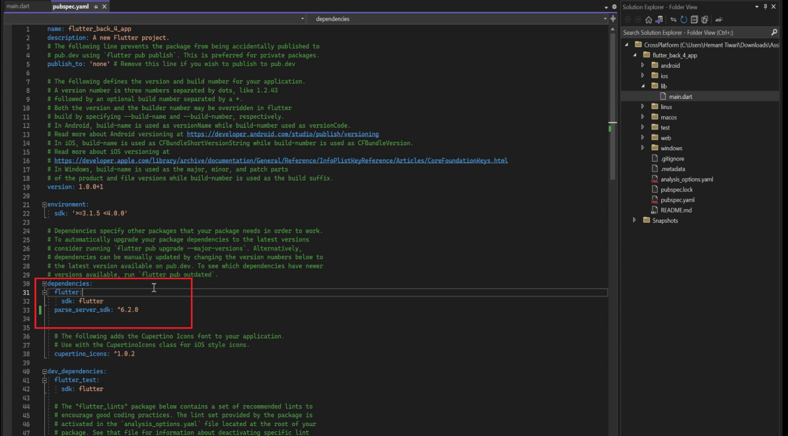

Update the keyApplicationId, final keyClientKey, and final keyParseServerUrl in In main.dart file. This is done so as to make sure connectivity between Flutter Application and Back4app.

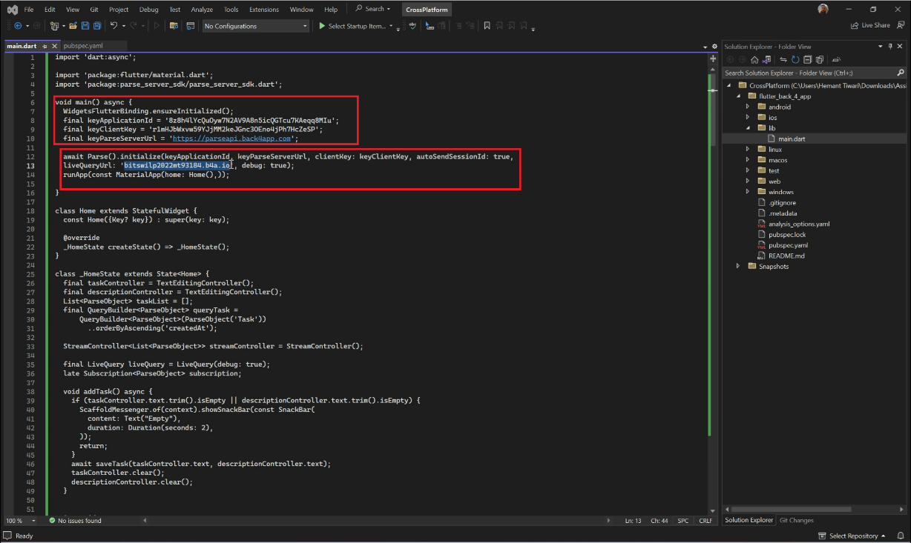

We can get these details from Back4app (App Settings >> Security & keys and App Settings >> General).

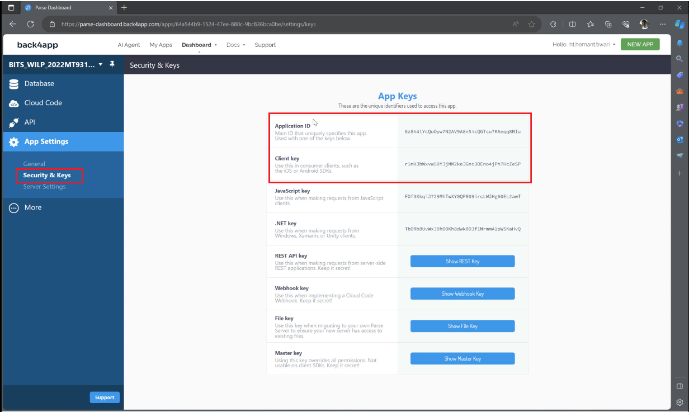

The Parse API “<https://parseapi.back4app.com>” is same for all the Back4App.

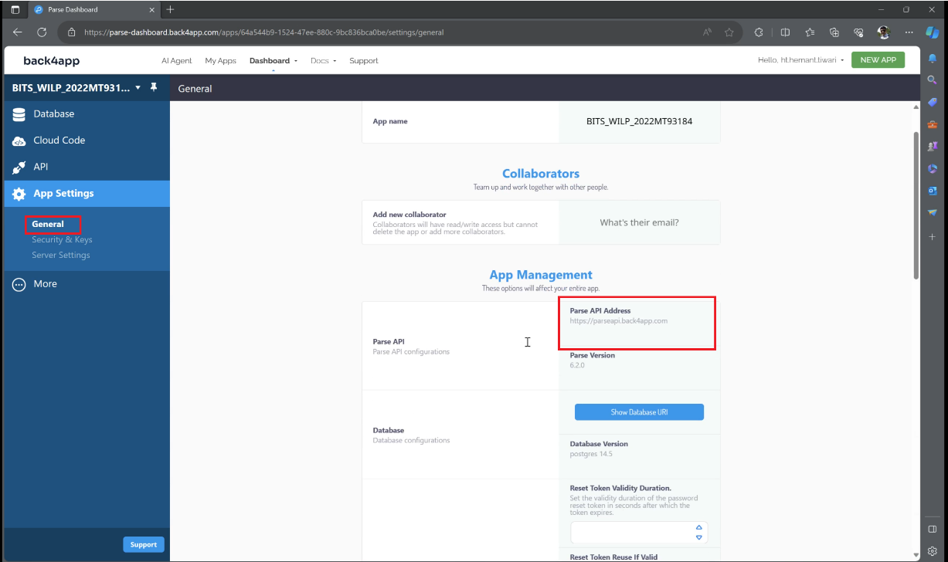

Since we are creating Interactive/Live Application therefore we need to make sure that Back4App subdomain is activated with Activating Live Query. This can be done from Server URL and Live Query (App Settings >> Server Settings >> Server URL and Live Query). The liveQueryUrl is updated in the main.dart file as shown above. This is unique to a Dashboard.

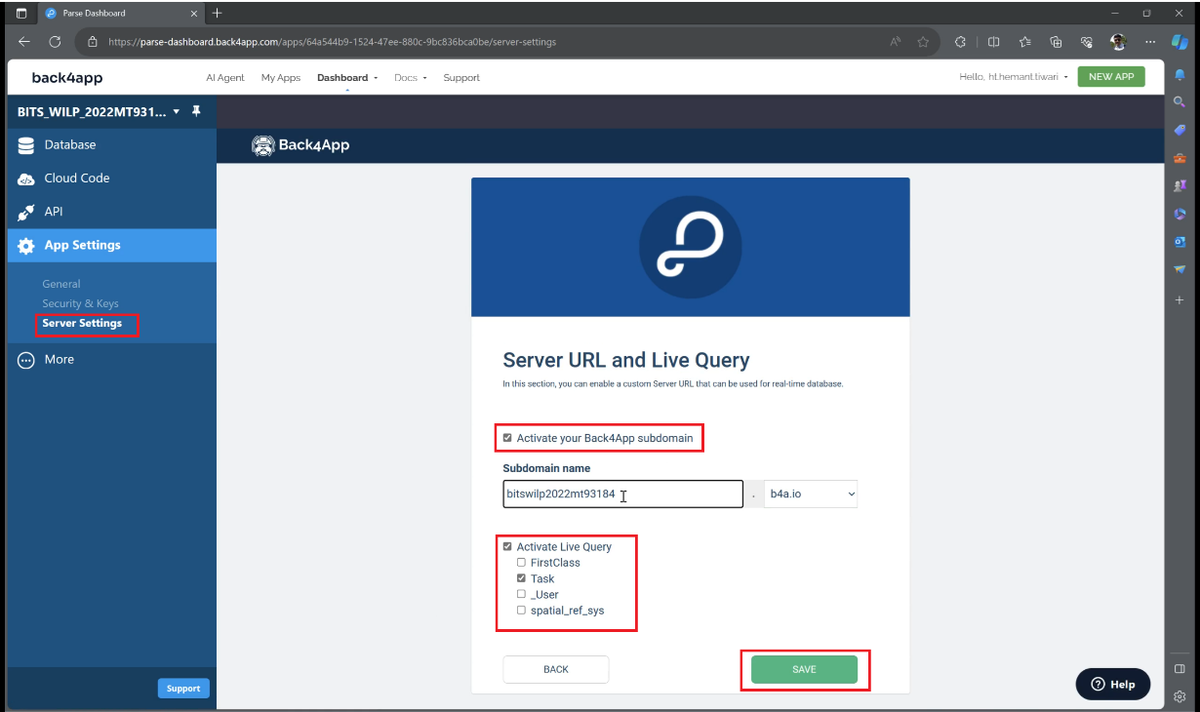

We need to startLiveQuery with CREATE, UPDATE, and DELETE. This is done to ensure that we are able to Make changes while running the application.

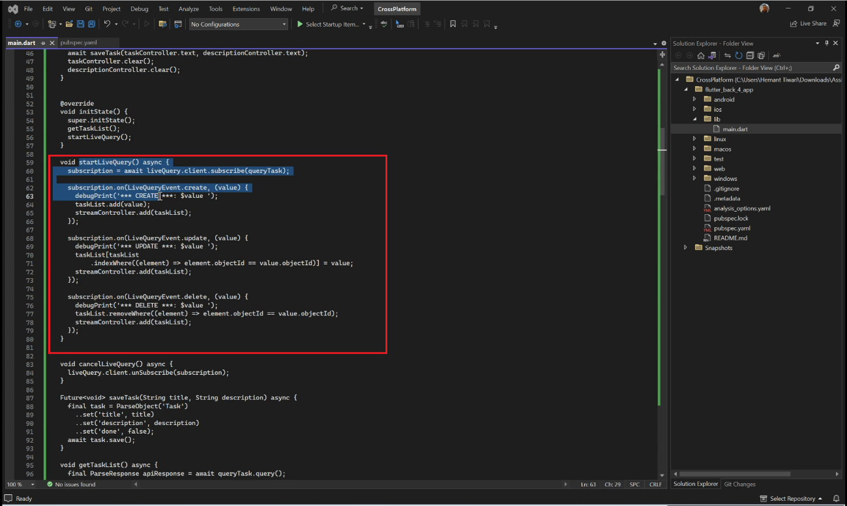

We will execute the code by running flutter run command.

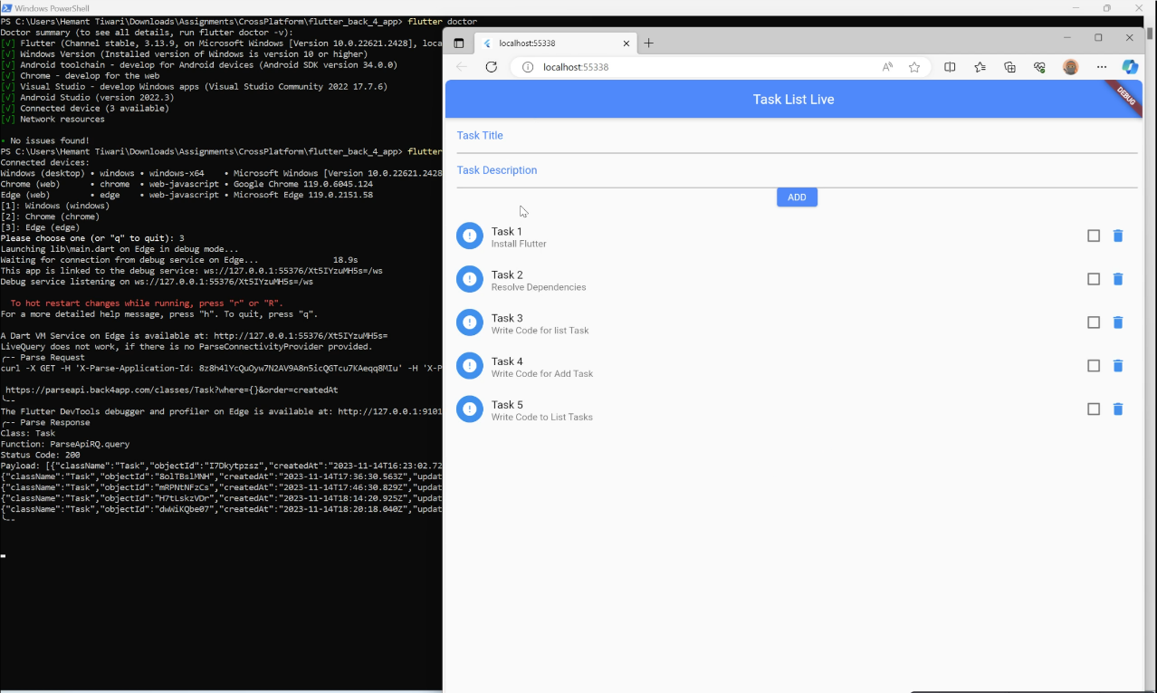

Adding task in Back4App will be update in flutter application.

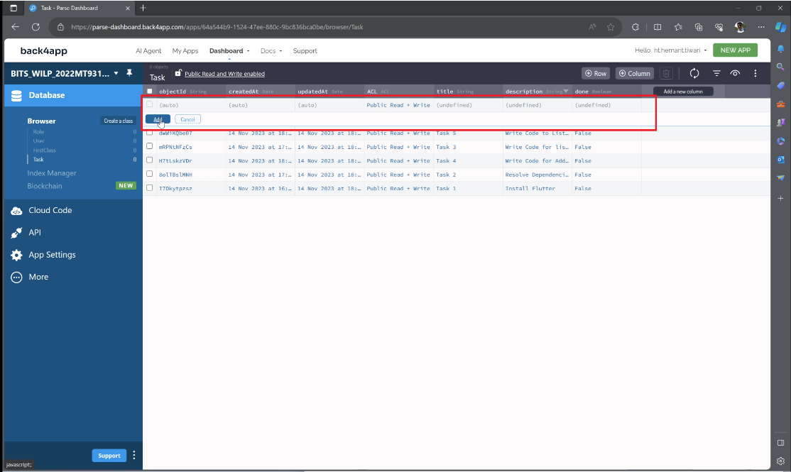

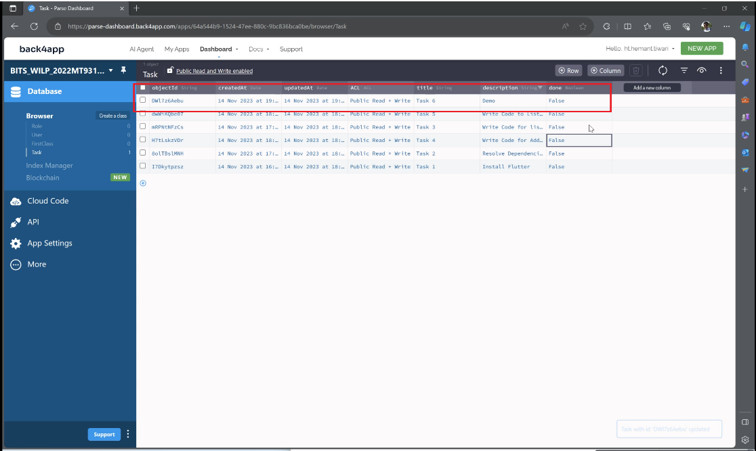

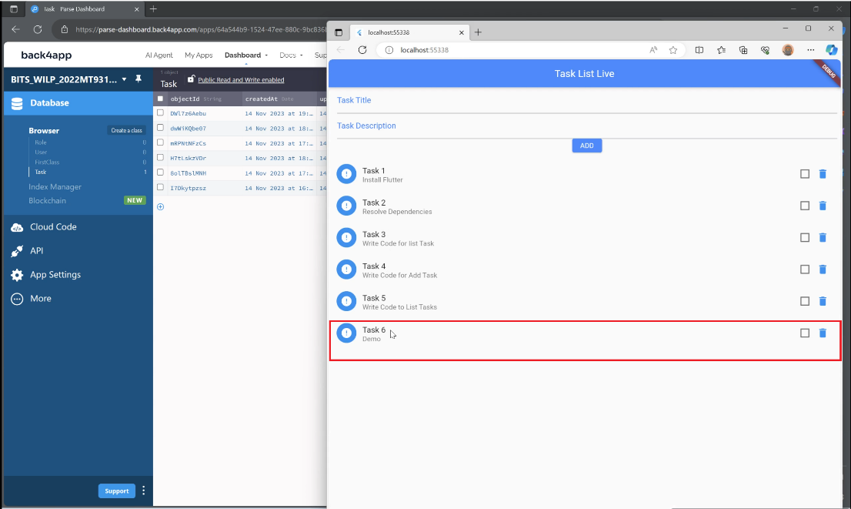

Updating the task in flutter application will be Updated in Back4app.

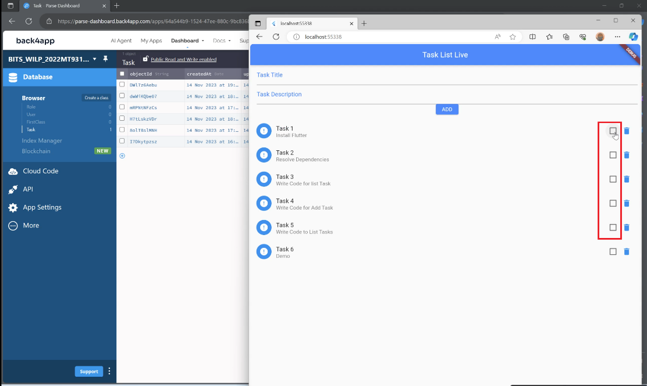

Deleting the task in flutter application will be Delete in Back4app.

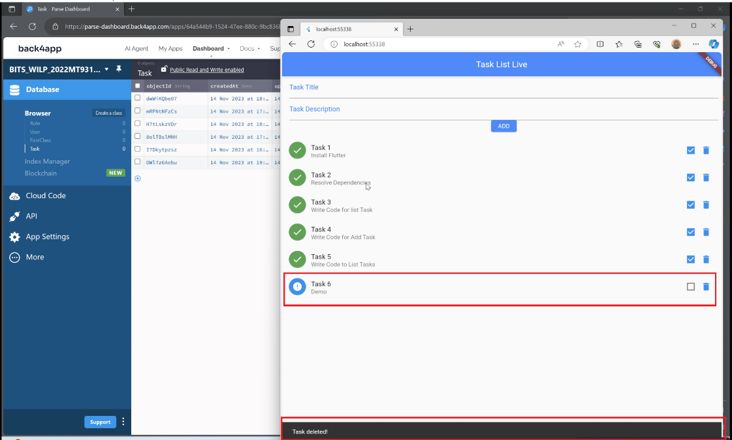

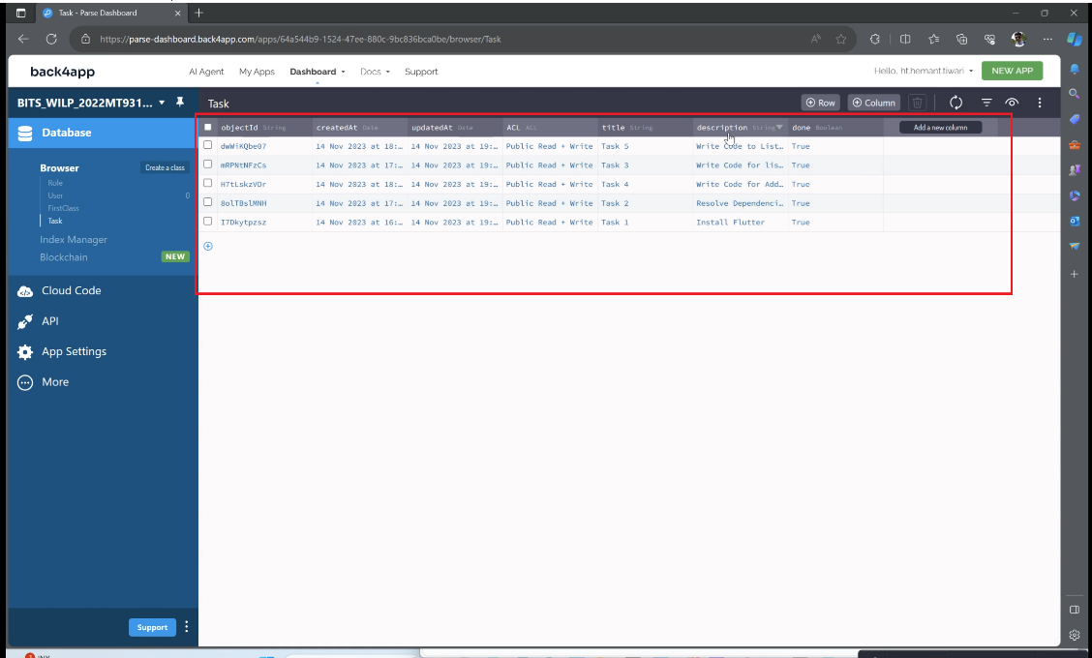

Adding in flutter application will add in Back4App.

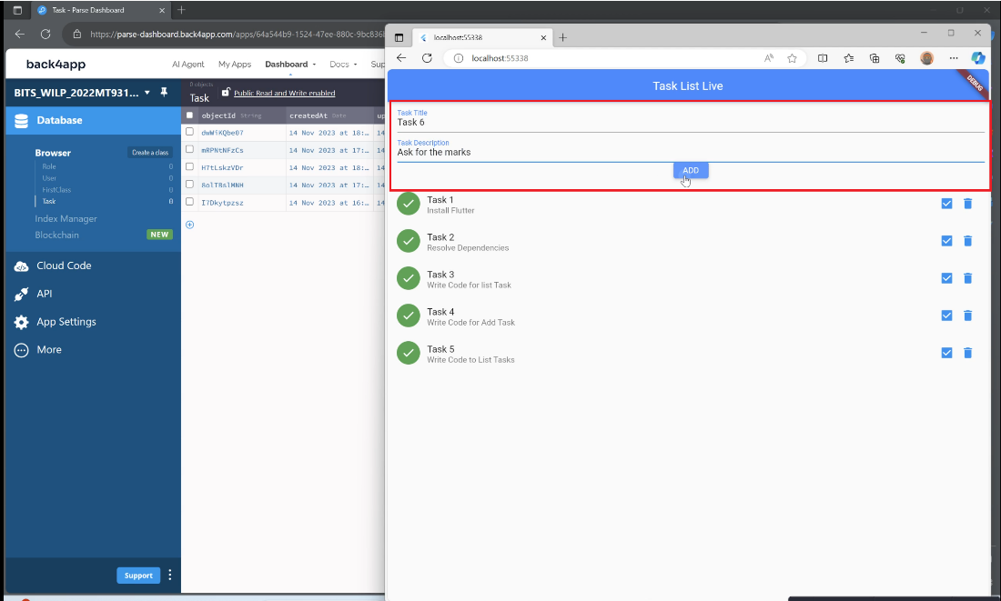

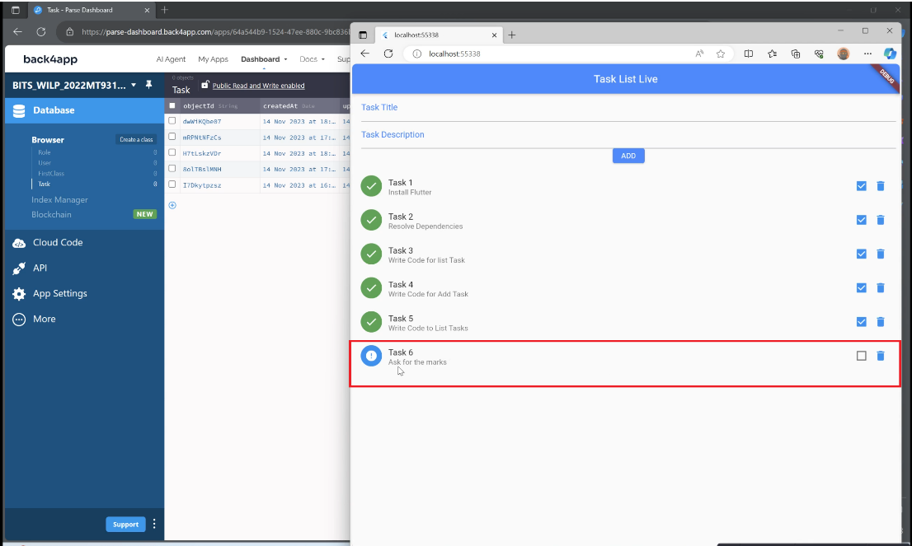

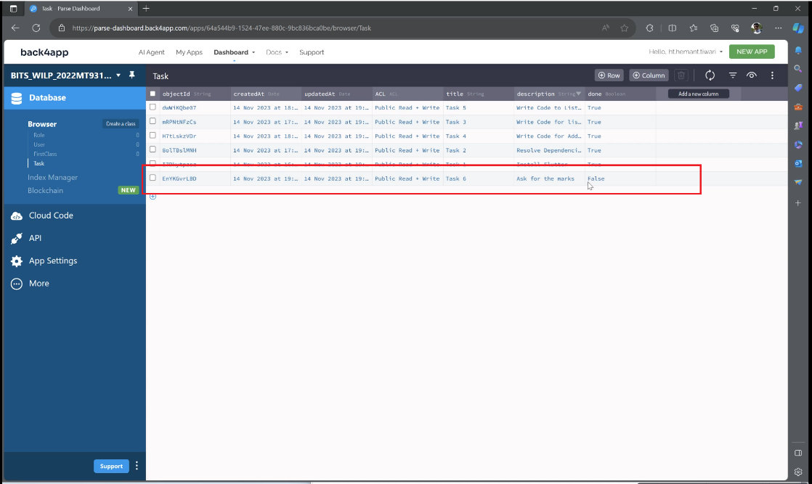

The Query Execution can be seen in the logs.

POST and GET (CREATE) Queries -

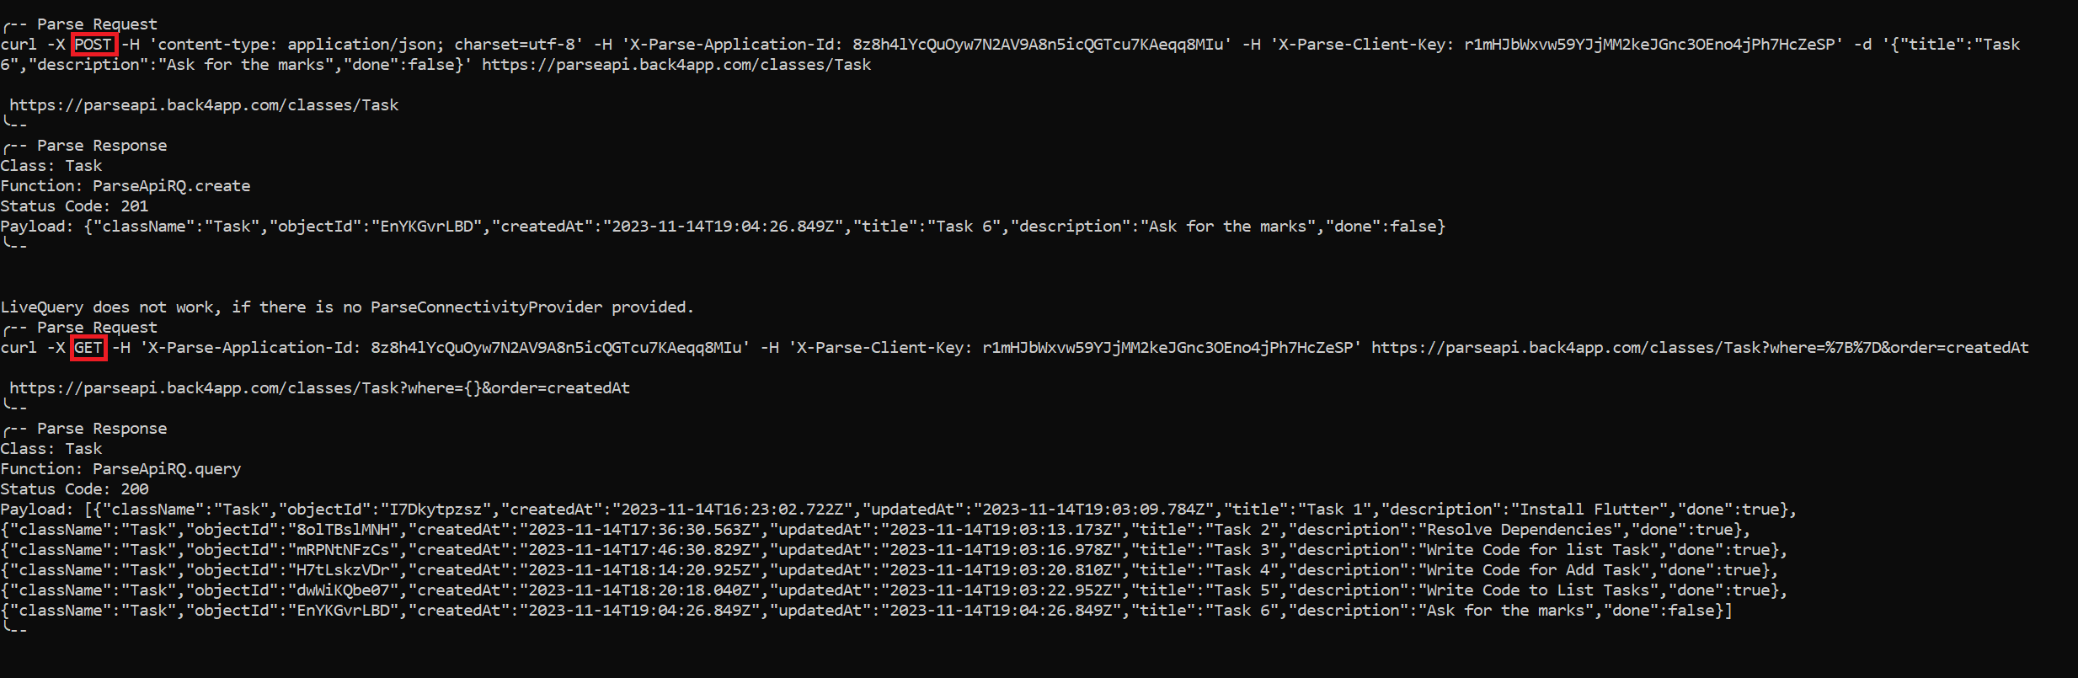

DELETE and GET (DELETE) Queries -

PUT and GET (UPDATE) Queries -

